

**Proposal for a New Academic Program**

**Institution:** Oregon State University - Cascades

**College/School:** College of Engineering

**Department/Program Name:** Electrical Engineering & Computer Science

**Degree and Program Title:** Bachelor of Science, Software Engineering

1. **Program Description**
2. Proposed Classification of Instructional Programs (CIP) number.

14.0903, Computer Software Engineering

1. Brief overview (1-2 paragraphs) of the proposed program, including its disciplinary foundations and connections; program objectives; programmatic focus; degree, certificate, minor, and concentrations offered.

The BS in Software Engineering educates students to become leaders in applying methodologies, technologies and tools for building long-lasting, high-quality, and maintainable software systems. It incorporates a project-driven experience and professional apprenticeship, both spanning all four years of the program. The curriculum design emphasizes new, innovative courses focusing on the software engineering body of knowledge while synthesizing fundamental courses in computer science.

Software engineering is the development (coding/programming), operation and maintenance of software, and the study of technical knowledge, methods, and experience to the design, testing and documentation of software (IEEE, 2010). It is an engineering discipline concerned with all aspects of software production. The classic definition, from the birth of software engineering in 1972, is “the establishment and use of sound engineering principles in order to economically obtain software that is reliable and works efficiently on real machines.” (Bauer, 1972). For the sake of this proposal, we define software engineering simply as *the multi-disciplinary study and practice of the technologies, principles, and methodologies in designing, testing, building and maintaining software*. There is demand for knowledgeable software engineers in both industry and research. As an academic pursuit, software engineering has grown into a body of knowledge that has long stood on its own (Bourque & Fairley, 2010).

Over the past decade, the market has responded to the lack of available software engineering education with “code schools” and “boot camps.” These programs offer skills-centered training on specific technology stacks (groups of tools and programming languages) to prepare the student for an entry-level software developer position. Despite their shortcomings, such programs have been immensely successful, changing students’ lives, catalyzing economic growth and educating students about the fundamentals of real-world computer programming. The problem with code schools is that they cannot cheat time. Some of the shortcomings of code school graduates include 1) only having surface knowledge of popular tools and technologies, 2) a lack of strong verbal and written communication skills, 3) a lack of strong critical thinking skills, 4) being trained for a specific job role, rather than as an adaptive learner, and 5) a lack of understanding of computer science fundamentals.

This academic program proposal presents a four-year Bachelor of Science in Software Engineering that synthesizes a liberal arts education with the principles of software engineering and the fundamentals of computer science.

1. Course of study – proposed curriculum, including course numbers, titles, and credit hours.

The software engineering program differs from computer science in that it *emphasizes* the communication skills, methodologies, tools, technologies, teamwork, professional practice, design, and architectures critical for building scalable, long-lasting software systems. The program emphasizes these software engineering principles over, but not at the exclusion of, computer science principles, such as algorithms, data structures, and machine architecture. The curriculum includes high-impact, team and project-based courses early in the curriculum, followed by computer science courses that explore the most important foundational and theoretical topics in computer science.

During year one, students engage in a team-based, real-world project in which they create a complete software system. This problem-driven approach includes pedagogy that introduces the breadth of topics in software engineering principles.

During year two, students engage in another project-based experience with a pedagogical focus on data: database management, data analysis, statistics, data mining, and data visualization.

Year three provides two main learning experiences. First, a third-year project experience focusing on scalability, security, and operations guides students toward mastering the software engineering program learning outcomes. Second, a “cornerstone” course, i.e. Elements of Computing Systems, teaches students how computation works by building a modern computing stack from the ground up, from logic gates to operating systems. This course, and the prior years’ experiences, form a foundation for students to begin focusing on computer science topics delivered via existing CS courses. Year four emphasizes entrepreneurship and the business of software, complemented by additional computer science courses (e.g. algorithms).

Lastly, throughout all four years of the curriculum, the software engineering program integrates experiential learning and professional practice. The program expects that each student be engaged in a professional apprenticeship throughout their academic career. The program shall employ a dedicated Apprenticeship Coordinator to manage the apprenticeship learning experience.

The program of study follows the degree standards at Oregon State University, incorporating both existing and new courses. The “SE” prefix indicates new courses, which are also followed by the CAT II proposal numbers (XXX).

🔑 **Freshman Skill Courses (16 cr)** 🎓 **BACC Core (48 cr)** 📓 **ABET Science & Math (46 cr)** 🖊 **WIC**

|  |
| --- |
| First Year 47 - 50 cr |
| Fall **16 - 18 cr**  CS 160 Computer Science Orientation (3)  WR 121 English Composition (3) 🔑🎓  HHS 231 Lifetime Fitness for Health (2) 🔑🎓  PAC XXX Various Physical Activity Courses (1) 🔑🎓  Bacc Core: Biological / Physical Science (4 - 5) 🎓📓  Bacc Core: Western Culture (3 - 4)🎓 |
| Winter **16 - 18 cr**  CS 161 Introduction to Computer Science I (4)  SE 107 Professional Seminar (1) (XXX)  MTH 112 Elementary Functions (4) 🔑🎓  Bacc Core: Biological / Physical Science (4 - 5) 🎓📓  Bacc Core: Literature & Arts (3 - 4) 🎓 |
| Spring **15 - 16 cr**  CS 162 Introduction to Computer Science II (4)  SE 110 Apprenticeship I (1) (XXX)  WR 327 Technical Writing (3) 🔑🎓  COMM 111 Public Speaking (3) 🔑🎓  Bacc Core: Physical Science (4 - 5) 🎓📓 |
| Second Year 48 - 50 cr |
| Fall **18 cr**  SE 201 Software Development I (4) (140903)  SE 211 Software Architecture I (4) (XXX)  SE 210 Apprenticeship II (1) (XXX)  CS 261 Data Structures (4)  PH 201 General Physics (5) 🎓📓 |
| Winter **16 - 17 cr**  SE 202 Software Development II (4) (XXX)  SE 212 Software Architecture II (4) (XXX)  PH 202 General Physics (5) 🎓📓  BACC Core: Social Processes & Institutions (3 - 4) 🎓 |
| Spring **14 - 15 cr**  SE 203 Software Development III (4) (XXX)  SE 213 Software Architecture III (4) (XXX)  CS 391 Social and Ethical Issues in Computer Science (3) 🎓  BACC Core: Difference, Power & Discrimination (3 - 4) 🎓 |
| Third Year 43 cr |
| Fall **15 cr**  SE 311 Elements of Computing Systems I (2) (XXX)  CS 361 Software Engineering I (4)  SE 310 Apprenticeship III (F/W/S) (1) (XXX)  MTH 251 Differential Calculus (4) 🔑🎓📓  ST 351 Intro to Statistical Methods (4) 🎓📓 |
| Winter **14 cr**  SE 312 Elements of Computing Systems II (2) (XXX)  CS 362 Software Engineering II (4)  MTH 252 Integral Calculus (4) 🎓📓  ST 352 Intro to Statistical Methods (4) 🎓📓 |
| Spring **14 cr**  SE 313 Elements of Computing Systems III (2) (XXX)  SE 303 Software Engineering III (4) (140903)  MTH 231 Elements of Discrete Mathematics (4) 📓  MTH 341 Linear Algebra (4) 📓 |
| Fourth Year 43 – 45 cr |
| Fall **15 - 16 cr**  CS 466 Web-Based Startup Project (4)  CS 461 Senior Software Engineering Project (3) 🖊  SE 410 Apprenticeship IV (F/W/S) (1) (XXX)  CS XXX Restricted Elective (4)  BACC Core: Contemporary Global Issues (3 - 4) 🎓 |
| Winter **15 cr**  SE 467 Business of Software II (4) (140903)  CS 462 Senior Software Engineering Project (3) 🖊  CS XXX Restricted Elective (4)  GEOG 360 Geographic Information Systems (4) |
| Spring **13 - 14 cr**  SE 468 Business of Software III (4) (140903)  CS 463 Senior Software Engineering Project (2)  CS XXX Restricted Elective (4)  BACC Core: Cultural Diversity (3 - 4) 🎓 |
| **Total Credit Hours 181 - 188** |

🔑 **Freshman Skill Courses (16 cr)** 🎓 **BACC Core (48 cr)** 📓 **ABET Science & Math (46 cr)** 🖊 **WIC**

**OSU Graduation Requirements**

180 total credits: 181 – 188 credits (140 major and 48 bacc core)

60 upper division credits: 74 upper division credits in major

**ABET Science & Mathematics (ABET, 2018b)**

One year of a combination of college level mathematics and basic sciences: 46 credits

One and one-half years of engineering topics: 90 credits

General education: 48 credits

Major design experience: CS 461 - 463

1. Manner in which the program will be delivered, including program location (if offered outside of the main campus), course scheduling, and the use of technology (for both on-campus and off-campus delivery).

The OSU-Cascades campus will deliver the Software Engineering program as a face-to-face, on-campus program in Bend, while housed within the OSU College of Engineering. The proposed curriculum schedules all existing (non-SE courses) according to the existing offerings at OSU-Cascades. Courses during the first two years of the curriculum may be scheduled and taken at two-year institutions, such as Central Oregon Community College in Bend, for transfer during a student’s pre-professional enrollment in the program. The program expects each student to own a laptop, and the program will leverage affordable third party services, such as cloud-based hosting and open source tools.

1. Adequacy and quality of faculty delivering the program.

OSU-Cascades currently offers a computer science program employing two full-time faculty and three to four adjunct instructors. OSU-Cascades plans to sunset computer science as the software engineering program starts, by ceasing enrollment in computer science and opening enrollment in software engineering. In addition, OSU-Cascades will hire one additional full-time faculty member, specializing in the field of software engineering, before the first year of the software engineering program. During the transition, these three full-time faculty will teach part of the remaining computer science courses and the new software engineering courses. In the future, OSU-Cascades will hire a fourth full-time faculty member, whose focus shall be research in software engineering or computer science education. The faculty include:

* Yong Bakos, MS Software Engineering, Instructor
  + With over twenty years of experience as a software engineer, and over ten years in computer science education, Bakos will lead the software engineering program.
  + Program administrator
  + Teaching 101, 102, 103, 107, 311, 312, 313
* Dr. Marc Rubin, PhD Computer Science, Instructor
  + Currently the computer science program lead at OSU-Cascades, Rubin will lead the delivery of the computer science courses in the new software engineering curriculum.
  + Teaching SE 201, 202, 203, 301, 302, 303, and CS 261 and 381
* Third full-time faculty member, PhD, Assistant Professor
  + An upcoming hire, this role represents a tenured or tenure-track position with research in the field of software engineering or computer science education.
  + Teaching SE, 401, 402, 403, and CS 325, 344, and 391.
* One to two part-time instructors, software professionals in the field
  + OSU-Cascades has successfully employed software professionals employed in Bend, specializing in software engineering, usability, networking, security, web and mobile software development, and computer science topics.

1. Adequacy of faculty resources – full-time, part-time, adjunct.

Beyond the faculty listed in section 1e, above, OSU-Cascades envisions hiring up to two additional full-time faculty and/or multiple part-time faculty to teach additional sections of courses. Based on prior experience, the Bend business environment offers a strong and growing pool of part-time faculty with real-world experience in software engineering.

1. Other staff.

Current OSU-Cascades staff will manage recruitment, enrollment, and advising until program growth dictates the need for additional staff. Existing faculty shall manage the program’s apprenticeship component for the first two years after the program begins. We intend to employ a full-time Program Assistant & Apprenticeship Coordinator to manage apprenticeships, act as an industry liaison, and coordinate the apprenticeship learning experience for students.

1. Adequacy of facilities, library, and other resources.

The two current full-time faculty currently occupy individual offices, and OSU-Cascades has an additional office for the third full-time faculty. Part-time faculty do not require dedicated office space.

Existing classroom facilities are adequate and already exist to support the software engineering program. The program will ideally utilize the “Learning Studio” (Figure 1) on the OSU-Cascades campus, but any existing classrooms are sufficient.

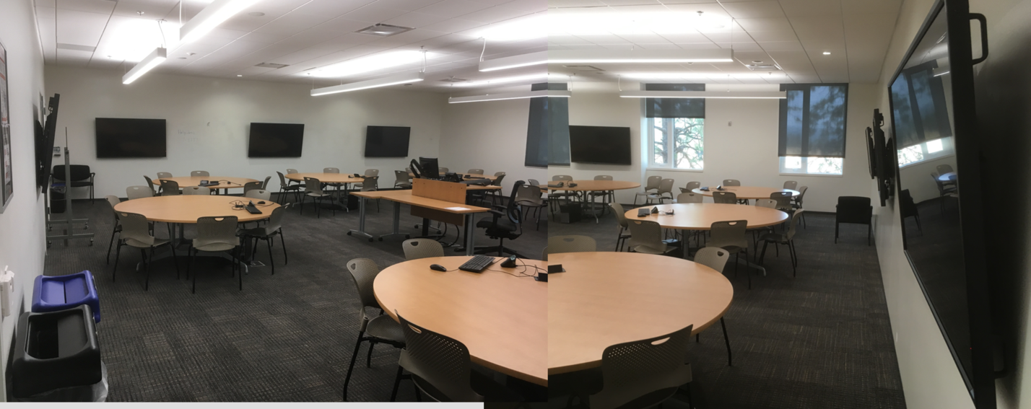

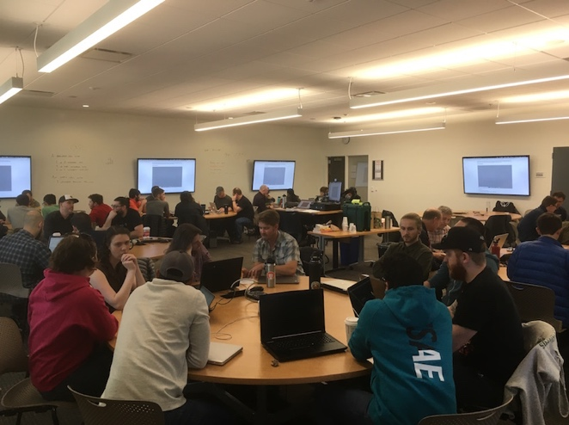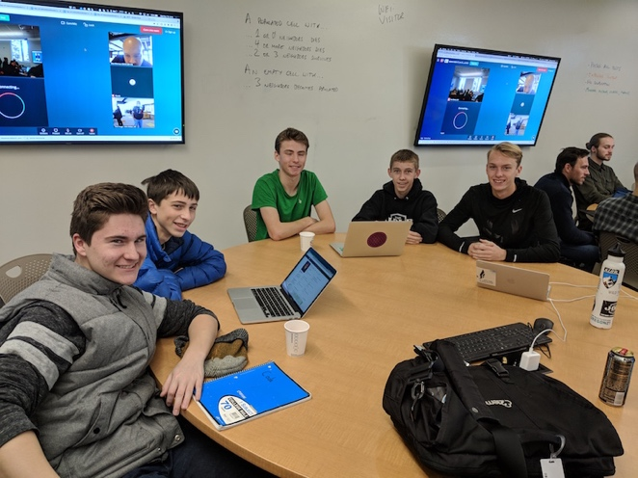

Figure 1: OSU-Cascades Learning Studio

With the planned expansion of the OSU-Cascades campus, sufficient classroom and office space will be available (see Facilities Evaluation).

The existing library resources were judged as satisfactory (see Library Evaluation).

1. Anticipated start date.

The software engineering program begins Fall 2019.

We anticipate Winter 2018 for program approval, and we will begin recruitment of our first cohort of students at that time. In Fall 2019, we will offer our undergraduate pre-professional coursework. Winter 2020 will be our first round of admissions for the junior cohort with professional coursework to start in Fall 2021.

1. **Relationship to Mission and Goals**
2. Manner in which the proposed program supports the institution’s mission, signature areas of focus, and strategic priorities.

*As a land grant institution committed to teaching, research and outreach and engagement, Oregon State University promotes economic, social, cultural and environmental progress for the people of Oregon, the nation and the world* (OSU, 2017).

The Software Engineering program incorporates effective, research-supported pedagogy within a hands-on classroom and curriculum design, organizes opportunities for student and faculty outreach into the community of Central Oregon, and integrates economic, social, cultural and environmental issues through world-relevant coursework and professional practice.

*This mission is achieved by producing graduates competitive in the global economy, supporting a continuous search for new knowledge and solutions and maintaining a rigorous focus on academic excellence… (OSU, 2017)*

The Software Engineering program aspires to become a world-class educational experience that transforms its students into emerging leaders who can design and deliver large, scalable, high-performing, and maintainable software systems (an area of high demand across the global economy). The cross-disciplinary, project-based curriculum design, integration with professional practice, synthesis of computer science topics, and incorporation of continuously evolving technologies supports the achievement of the OSU mission.

*…particularly in the three Signature Areas: Advancing the Science of Sustainable Earth Ecosystems, Improving Human Health and Wellness, and Promoting Economic Growth and Social Progress (OSU, 2017).*

We intend for the subject areas of the Software Engineering program to focus on systems that support researchers and practitioners in sustainability, ecology, human health and wellness, and economic and social progress. Specifically, students within Software Engineering will build systems in collaboration with students and faculty of Energy Systems Engineering, Biology, Natural Resources, Sustainability, Kinesiology, Human Development & Family Science, Hospitality Management, and Business. For example, students may engineer a software system that transmits, aggregates, mines and visualizes sensor data for river restoration; they may engage with a local medical device company to improve software reliability and security, or build applications that assist the disabled. Moreover, SE students may integrate new systems, techniques and solutions that they bring to market through their own startup business, creating new jobs and economic growth. Furthermore, our intent is to distill a minor in Software Engineering that students of all majors may take to complement their main degree program.

Strategically, one priority for the OSU-Cascades campus is to distinguish itself with innovative, world-class, “destination degree programs” not offered at most institutions. The Software Engineering program exemplifies these qualities, following the success of the existing Energy Systems Engineering program and co-existing with other innovative new programs such as Outdoor Products.

1. Manner in which the proposed program contributes to institutional and statewide goals for student access and diversity, quality learning, research, knowledge creation and innovation, and economic and cultural support of Oregon and its communities.

The Software Engineering program approaches student access and diversity as a continuum, beginning with K-12 outreach (Bush & Miller, 2017; Wilson et al, 2010) and bringing K-12 students onto campus to observe Software Engineering classes and students (Engle et al, 2006). The program ensures an approachable introductory course sequence for students with diverse backgrounds (Cohoon & Tychonievich, 2011), implements an authentic, hands-on, and world-relevant active learning experience (Eisenberg, 2017), cultivates a community of supportive peers through specific learning methods (Nagappan, 2013), and integrates professional exposure early in the curriculum, to support student career-readiness upon graduation.

The Software Engineering program has, as its advantage, the ability to immediately implement effective teaching and learning techniques, and experiences for knowledge creation, based on decades of prior research in engineering and computer science education. An advantage of the proposed SE program is its ability to implement proven pedagogical methods, based on decades of prior research, directly into its new curriculum. Furthermore, the engagement of real-world problems, solicited from local, regional and statewide businesses directly contributes to innovation, economic and cultural support of Oregon.

1. Manner in which the program meets regional or statewide needs and enhances the state’s capacity to:
2. improve educational attainment in the region and state;
3. respond effectively to social, economic, and environmental challenges and opportunities; and
4. address civic and cultural demands of citizenship.

Central Oregon is an education desert or a “community where students have few postsecondary options from which they can choose.” Nationally, students travel less than 50 miles to attend a 4-year public university (Figure 2). OSU-Cascades is a critical player in the social and economic development of Central Oregon and cannot serve the needs of the students and employers of the region without further expansion of academic programs and degrees. In addition, Central Oregon Community College’s role cannot be understated in Central Oregon, where over 86% of all students in higher education are enrolled. The Software Engineering program capitalizes on the lower division preparation provided by COCC to remote communities to recruit diverse students. By working in partnership with COCC, we have created a pathway to the undergraduate degree that can be started at either institution.

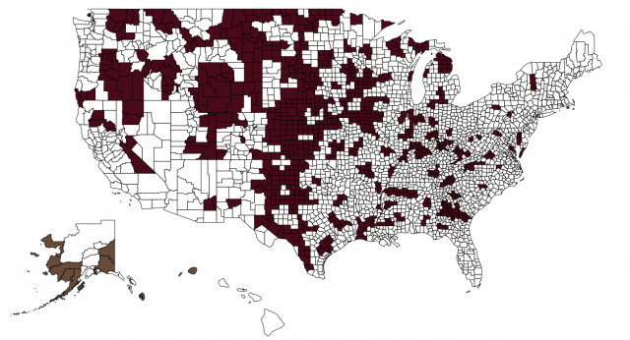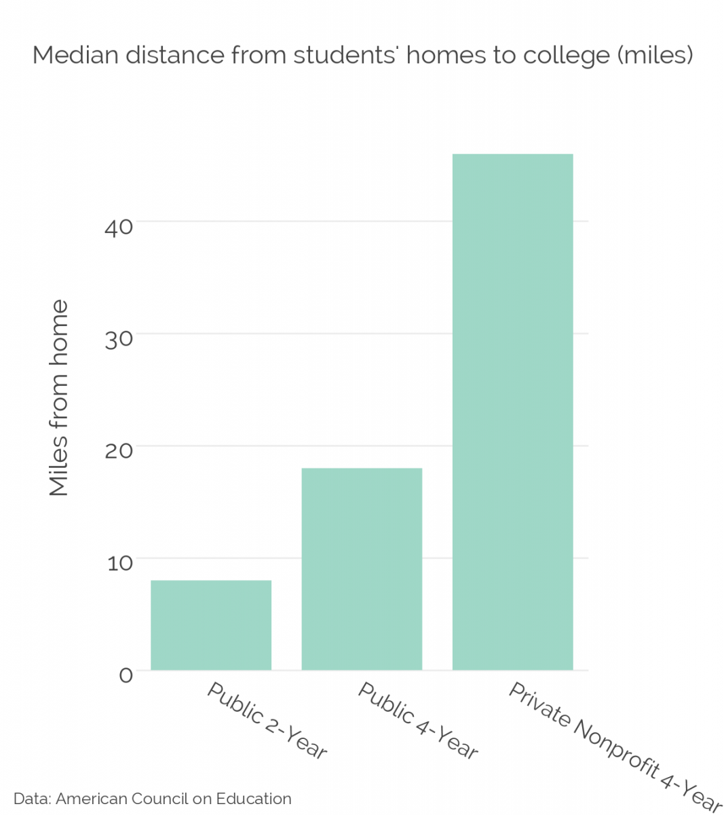

Figure 2: “The zip code that a child is born into oftentimes determines their life chances.” (Hillman & Weichman, 2016)

1. **Accreditation**
2. Accrediting body or professional society that has established standards in the area in which the program lies, if applicable.

The Accreditation Board for Engineering and Technology (ABET) provides accreditation to engineering programs in the United States. The Computing Sciences Accreditation Board (CSAB) leads the ABET Engineering Accreditation Commission. Members include the Association of Computing Machinery (ACM) and the Institute of Electrical and Electronics Engineers (IEEE).

1. Ability of the program to meet professional accreditation standards. If the program does not or cannot meet those standards, the proposal should identify the area(s) in which it is deficient and indicate steps needed to qualify the program for accreditation and date by which it would be expected to be fully accredited.

The Software Engineering program outcomes and quality assessment (Section 5) specifically include the outcomes and standards set forth by the Criteria for Accrediting Engineering Programs (ABET, 2017b). The courses and course learning outcomes cover the “breadth and depth of engineering and computer science topics” in the Program Criteria for Software and Similarly Named Engineering Programs (ABET, 2017b). Identical to the accreditation criteria, the Software Engineering curriculum includes computing fundamentals, software design and construction, requirements analysis, security, verification, and validation; software engineering processes and tools appropriate for the development of complex software systems; and discrete mathematics, probability, and statistics, with applications appropriate to software engineering.

1. If the proposed program is a graduate program in which the institution offers an undergraduate program, proposal should identify whether or not the undergraduate program is accredited and, if not, what would be required to qualify it for accreditation.

N/A

1. If accreditation is a goal, the proposal should identify the steps being taken to achieve accreditation. If the program is not seeking accreditation, the proposal should indicate why it is not.

Following ABET guidelines, we will record data for the required Self-Study Report during the first three years of the Software Engineering program. We will submit a Request for Evaluation in the third year of the program, and plan to obtain accreditation by the program’s fourth or fifth year of operation (ABET, 2018a).

1. **Need**
2. Anticipated fall term headcount and FTE enrollment over each of the next five years.

We estimate the anticipated headcount and FTE enrollment growth based upon four factors:

1. Historic and current enrollments in the existing computer science program at OSU-Cascades.
2. The growth rate of computer science enrollments at OSU overall, and at similar institutions.
3. Enrollment growth in the Energy Systems Engineering program, just as a model for new engineering program growth at OSU-Cascades.
4. Overall enrollment growth at OSU-Cascades.

|  |  |  |  |  |  |
| --- | --- | --- | --- | --- | --- |
|  | 2019 | 2020 | 2021 | 2022 | 2023 |
| Enrollment | 12 | 25 (13) | 39 (14) | 55 (16) | 73 (18) |

Table 1. Annual enrollment, with new enrollments in parentheses.



Figure 3: Anticipated enrollments of CS and SE at OSU-Cascades.

1. Expected degrees/certificates produced over the next five years.

We anticipate awarding twelve Bachelor of Science, Software Engineering degrees in the spring of 2023. We anticipate awarding thirteen, fourteen, sixteen and eighteen degrees in the subsequent five years.

1. Characteristics of students to be served (resident/nonresident/international; traditional/ nontraditional; full-time/part-time, etc.).

The program will serve resident, nonresident, and international students. The program will serve traditional and nontraditional students. The program will serve full-time and part-time students. We base this estimate on the current demographic of students served at OSU-Cascades and within the existing computer science program at OSU-Cascades.

1. Evidence of market demand.

The current Bureau of Labor Statistics indicate that, in 2016, Software Developers had the highest annual median pay of computer information system professionals, at $102,280, with an entry-level education of a Bachelor’s degree (US Dept. of Labor, 2017). In 2015, the Bureau predicted a demand of 1.4 million jobs, but only 400,000 computer science graduates, leaving the market with a shortage of 1 million software engineers despite surging enrollments in computer science programs (CRA, 2017). But computer science programs are not software engineering programs (Parnas, 1999). Furthermore, analyses from the Economic Policy Institute reveal that less than one-half of workers in these occupations have a computer science degree (Costa, 2012).

In recent years, code schools around the world have demonstrated the massive market demand for software engineering education, seen as an alternative to the four-year computer science degree (Roy, 2016). While code schools have typically offered two to six-month programs, new initiatives such as the Academy for Software Engineering, multi-year code schools such as the Holberton School, and four-year institutions such as Berlin’s CODE University of Applied Sciences indicate an increasing demand for more intensive software engineering education. Interestingly, there are not many undergraduate software engineering programs at four-year institutions, and ABET currently reports only twenty-seven accredited software engineering programs in the United States.

Lastly, this proposal includes specific letters expressing demand for this software engineering program from the local business community surrounding OSU-Cascades, companies and educators in the state of Oregon, and companies and software engineering professionals within the United States.

1. If the program’s location is shared with another similar Oregon public university program, the proposal should provide externally validated evidence of need (e.g., surveys, focus groups, documented requests, occupational/employment statistics and forecasts).

The OSU-Cascades software engineering program will begin at the same time that its computer science program will cease accepting enrollments. While they may co-exist for a short time within our institution, the software engineering program will not share its location with another similar program.

Within the state of Oregon, the software engineering shares a presence with computer science programs at numerous Oregon universities, include OSU (Corvallis), Portland State, and University of Oregon. The Oregon Institute of Technology campus in Klamath Falls is the only Oregon institution that offers a similar program, Software Engineering Technology.

Employment statistics and forecasts are documented in section *d*, above, and this proposal includes documented requests for this proposed software engineering program.

1. Estimate the prospects for success of program graduates (employment or graduate school) and consideration of licensure, if appropriate. What are the expected career paths for students in this program?

We expect that graduates of the OSU-Cascades software engineering program will find successful careers as software engineers within local, state, national, and multinational businesses. In addition, the software engineering program will prepare students for graduate programs in software engineering and data science.

Labor statistics and job market trends indicate a strong ongoing demand for graduates of the software engineering program.

1. **Outcomes and Quality Assessment**
2. Expected learning outcomes of the program.

The software engineering program adheres to ABET-defined student learning outcomes (ABET, 2017b).

1. an ability to apply knowledge of mathematics, science, and engineering
2. an ability to design and conduct experiments, as well as to analyze and interpret data
3. an ability to design a system, component, or process to meet desired needs within realistic constraints such as economic, environmental, social, political, ethical, health and safety, manufacturability, and sustainability
4. an ability to function on multidisciplinary teams
5. an ability to identify, formulate, and solve engineering problems
6. an understanding of professional and ethical responsibility
7. an ability to communicate effectively
8. the broad education necessary to understand the impact of engineering solutions in a global, economic, environmental, and societal context
9. a recognition of the need for, and an ability to engage in life-long learning
10. a knowledge of contemporary issues
11. an ability to use the techniques, skills, and modern engineering tools necessary for engineering practice
12. Methods by which the learning outcomes will be assessed and used to improve curriculum and instruction.

We will map each program learning outcome to specific formative, qualitative and quantitative assessments of software engineering activities within the courses of the curriculum. At the end of each term, the program leadership shall collect and analyze each assignment and three student samples of each assessment, representing high, average and low quality. The results of the analysis shall drive indicators for assignment improvement in meeting the program learning outcomes.

Each year, program leadership shall also aggregate outcome-related assessments for all students, “scoring” them against the program learning outcomes. Outcomes with a significant number of students who rank poorly shall drive indicators for improving curriculum and instruction related to those outcomes.

In addition, all faculty shall engage in a peer classroom observation once per term, mid-term student feedback evaluations, and end-of-term student evaluations.

1. Nature and level of research and/or scholarly work expected of program faculty; indicators of success in those areas.

The software engineering program expects faculty to be practitioners and instructors of software engineering. Scholarly work includes contributions to open source software, implementations of new languages or development tools, and innovations within design, project management, and methodology. Indicators of success include:

* Mentoring undergraduate apprentices who find success in the field
* Presenting at conferences
* Creating and managing widely used, successful open source projects
* Publishing technical books related to software engineering
* Publication in peer-reviewed literature
* Engagement as a software engineering consultant
* Securing external funding that supports undergraduate or graduate student researchers
* Industry-recognized awards
* Certifications in particular technologies or methodologies

1. **Program Integration and Collaboration**
2. Closely related programs in this or other Oregon colleges and universities.

Oregon Institute of Technology offers a degree in Software Engineering Technology. OSU-Cascades currently offers a degree in computer science, which we intend to replace with the new software engineering program. OSU will continue to offer computer science on its main campus in Corvallis, as well offer its post-bacc online program in computer science. The following Oregon institutions offer a degree in computer science.

* Eastern Oregon University
* George Fox University
* Lewis & Clark College
* Linfield College
* Pacific University
* Portland State University
* Reed College
* Southern Oregon University
* University of Oregon
* University of Portland
* Western Oregon University
* Willamette University

Lastly, the community colleges in Oregon, such as Central Oregon Community College, offer a two-year associates degree in computer science.

1. Ways in which the program complements other similar programs in other Oregon institutions and other related programs at this institution. Proposal should identify the potential for collaboration.

We intend to establish clear articulation agreements for course credits for students who transfer into and out of the software engineering program at OSU-Cascades. For example, a student who has completed CS 160, 161 and 162 may receive credit for SE 101, 102 and 103. Students should be able to receive credit for equivalent computer science courses taken in either the CS or SE programs. In particular, we intend to align some of the learning outcomes of the first two years of software engineering courses with the first two years of courses in the computer science program at OSU. This will enable students to transfer between the CS and SE programs during their first two years at OSU. The learning outcomes of 100 and 200 level courses shall drive the discussion of these articulation agreements.

The articulation agreement of CS courses also applies to community colleges, which is particularly important given the intent of ASOT / AAOT degree programs. These programs have enabled students to complete the first two years of a computer science degree at an Oregon community college and complete the second two years at a four-year institution. While the impact of no longer offering computer science at OSU-Cascades is addressed in section *d* below, we intend to define a clear articulation agreement for the CS courses of the associates degree. Furthermore, we intend to collaborate with Central Oregon Community college to lead the way with a new ASOT for software engineering in the state of Oregon.

We are engaged in a collaborative dialog with Oregon Institute of Technology regarding the software engineering program. While similar in name, the OIT program meets different ABET criteria, has different learning outcomes, and consists of a different curriculum. We intend to share our experience of the new software engineering program, and learn from OIT’s experience, to help define what works well and what does not.

Lastly, we envision the software engineering program to be a fertile ground for computer science education research and, humbly, a transformative influence on the future of CS/SE education. We intend for our faculty to collaborate with CS education researchers at OSU and other universities, to enable new contexts for data gathering, experimentation and research.

1. If applicable, proposal should state why this program may not be collaborating with existing similar programs.

N/A

1. Potential impacts on other programs.

The new software engineering program will directly impact the existing computer science program at OSU-Cascades. We intend to replace the computer science program with the software engineering program. Our current plan is to cease accepting enrollments in computer science as we begin accepting enrollments for software engineering. At the same time, existing computer science faculty will begin to teach more of the software engineering courses, and fewer of the computer science courses, until the transition is complete. Students enrolled in computer science during the co-existence of both programs may transfer into the software engineering degree. Because not all of the computer science courses count toward the software engineering program, we intend to:

* Advise computer science students about the co-existence of the software engineering program
* Clearly articulate how computer science courses may or may not be transferred toward the software engineering degree
* Encourage students, especially third and fourth year students, who intend to transfer into software engineering, to be strategic about the computer science courses they enroll in, to ensure ease of transfer
* Pay special care about the social and organizational impacts during the first few years of the software engineering program

OSU-Cascades intends for the software engineering program to be a successful replacement for an existing, healthy computer science program. This new program entails some risk: will students come? While we recognize the market demand for this new program, we also recognize the importance of marketing and communication and will execute accordingly. Despite these risks and complications, anecdotal evidence and unofficial surveying of our existing computer science students indicates excitement, strong interest, and mild envy about this new program in software engineering.

A second potential impact of the new software engineering program is that of its effect on the computer science program on the OSU Corvallis campus. We see the following positive impacts:

* Reduced confusion about two computer science programs on separate campuses
* New program innovation for OSU, complementing existing programs in the College of Engineering
* Absorbing some of the surging enrollment growth in computer science, especially for those students who wish to focus on software engineering

We foresee the need to work closely with advisors to clearly articulate the difference between the software engineering and computer science programs. We will need to plan our approach on advising students, especially those early in the computer science program, who may wish to transfer to software engineering from CS in Corvallis. We will also need to advise students who may wish to transfer from the software engineering program into the CS program in Corvallis.

Lastly, we recognize the impact on the ability for students at Central Oregon Community College, and other Oregon state institutions, in transferring from computer science to a program at OSU-Cascades. Currently, students completing the ASOT-CS degree receive credit for CS 160, 161 162 and 260/261. These are the common CS courses taken during the first two years of computer science at Oregon institutions. We intend to allow these CS courses to satisfy the requirements of SE 101, 102 103 and CS 261 within the software engineering program. However, this leaves an ASOT-CS transfer student with the need to enroll in additional first and second year software engineering courses, such as SE 111, 112 and 113, before they may progress through the remainder of the software engineering program. We believe in the importance of the ASOT model and we intend to work closely with the Oregon community college system to establish a new ASOT-SE program once the software engineering program reaches maturity.

**7. External Review**

If the proposed program is a graduate level program, follow the guidelines provided in *External Review of New Graduate Level Academic Programs* in addition to completing all of the above information.

The proposed software engineering program is not a graduate level program.

*Revised May 2016*

**References**

ABET (2018a). Accreditation Policy and Procedure Manual (APPM), 2018 – 2019. Retrieved from

<http://www.abet.org/accreditation/accreditation-criteria/accreditation-policy-and-procedure-manual-appm-2018-2019/>

ABET (2018b). Criteria for Accrediting Engineering Programs, 2018 – 2019. Retrieved from

<http://www.abet.org/accreditation/accreditation-criteria/criteria-for-accrediting-engineering-programs-2018-2019/>

Bauer, F.L. (1972). Software Engineering. *Information Processing* 71.

Bourque, P. & Fairley, R.E., eds. (2014).Guide to the Software Engineering Body of Knowledge, Version 3.0, IEEE Computer Society. Retrieved from: [www.swebok.org](http://www.swebok.org/).

Bush, J. & Miller, S. (2017). Analysis of Associations between Motivation and Previous Computer Science Experience, Gender, Ethnicity and Privilege as Observed in a Large Scale Survey of Middle School Students. In *Proceedings of the 2017 ACM SIGCSE Technical Symposium on Computer Science Education* (SIGCSE '17). ACM, New York, NY, USA, 705-705. doi:<https://doi.org/10.1145/3017680.3022441>

Cohoon, J. & Tychonievich, L. (2011). Analysis of a CS1 approach for attracting diverse and inexperienced students to computing majors. In *Proceedings of the 42nd ACM technical symposium on Computer science education* (SIGCSE '11). ACM, New York, NY, USA, 165-170. doi:<http://dx.doi.org/10.1145/1953163.1953217>

Computing Research Association (CRA). (2017). Generation CS: Computer Science Undergraduate Enrollments Surge Since 2006. Retrieved from: [*https://cra.org/data/Generation-CS*](https://cra.org/data/Generation-CS)

Costa, D. (2012). STEM labor shortages? *Policy Memorandum #195*. Economic Policy Institute. Retrieved from <http://www.epi.org/publication/pm195-stem-labor-shortages-microsoft-report-distorts/>

Eisenberg M. (2017) Approaching Computer Science Education Through Making. In: Fee S., Holland-Minkley A., Lombardi T. (eds) *New Directions for Computing Education*. Springer, Cham. doi:<https://doi.org/10.1007/978-3-319-54226-3_3>

Engle, J., Bermeo, A., O’Brien, C. (2006). Straight from the Source: What Works for First-Generation College Students. Washington, DC: Pell Institute for the Study of Opportunity in Higher Education. Retrieved from<http://www.pellinstitute.org/downloads/publications-Straight_from_the_Source.pdf>

Hillman, N. & Weichman, T. (2016). Education Deserts: The Continued Significance of “Place” in the Twenty-First Century. *Viewpoints: Voices from the Field*. Washington, DC: American Council on Education. Retrieved from<http://www.acenet.edu/news-room/Documents/Education-Deserts-The-Continued-Significance-of-Place-in-the-Twenty-First-Century.pdf>

IEEE. (2010). Systems and software engineering – Vocabulary. *ISO/IEC/IEEE 24765:2010(E)* pp.1-418, Dec. 15 2010 doi: 10.1109/IEEESTD.2010.5733835

Lohr, S. (2017). Where the STEM Jobs Are (and Where They Aren’t). *The New York Times*. Retrieved from <https://www.nytimes.com/2017/11/01/education/edlife/stem-jobs-industry-careers.html?smid=pl-share>

Nagappan, N., Williams, L., Ferzli, M., Wiebe, E., Yang, K., Miller, C., & Balik, S. (2003). Improving the CS1 experience with pair programming. In *Proceedings of the 34th SIGCSE technical symposium on Computer science education* (SIGCSE '03). ACM, New York, NY, USA, 359-362. DOI=http://dx.doi.org/10.1145/611892.612006

Oregon State University (2017). Oregon State University Mission Statement. Retrieved from<http://leadership.oregonstate.edu/trustees/oregon-state-university-mission-statement>

Parnas, D. (1999). Software engineering programs are not computer science programs. *IEEE Software, 16*(6), pp 19-30, Nov/Dec. doi: 10.1109/52.805469

Roy, A. (2016). Coding boot camps replace college for software engineers. CNBC. Retrieved from <https://www.cnbc.com/2016/08/26/coding-boot-camps-replace-college-for-software-engineers.html>

United States Department of Labor, Bureau of Labor Statistics. (2017). *Occupational Outlook Handbook*. Retrieved from <https://www.bls.gov/ooh/computer-and-information-technology/home.htm>

Wilson, C., Sudol, L. A., Stephenson, C. & Stehlik, M. 2010. Running on Empty: The Failure to Teach K-12 Computer Science in the Digital Age. The Association for Computing Machinery & The Computer Science Teachers Association. Retrieved from http://runningonempty.acm.org/fullreport2.pdf